

**University of Babylon**

**Third Stage**

**Morning Study**



**Written by : Linha Mohammed**

**Supervision : Prof. Dr. Ahmed Saleem Abbas Alsaffar ,**

**And: Mrs. Alia Muhammad Reda Abdul Kadhim**

**Software Engineering With Team Project**

**Project name**

**SNOW-WIGHT Dental Clinic**

**Project Idea**

**Dental clinic website**



**Team members**

**Linha Mohammed - Leader**

**Manar Yhaya**

**Mohammed Jafar**

**Summary of the program**

**1** Our project represents a dental clinic.

**2** Despite the importance of visiting the dentist periodically, they postpone it due to the obstacles they face, so we endeavor to provide all the patient's information needs.

**3** We also seek to solve all problems that may face both the doctor and the patient for example:

* We provide real-life examples for every doctor along with their assessment.
* There is also a calendar that includes the times of each doctor's presence to facilitate the reservation process.

**WBS**

|  |  |  |  |  |
| --- | --- | --- | --- | --- |
| **No.** | **Task** | **Duration** | **start** | **End** |
| **1** | **Preparing problem statement** | **6 Days** | **20/5/2021** | **25/5/2021** |
| **2** | **Understanding general**  **requirements** | **2 Days** | **26/5/2021** | **28/5/2021** |
| **3** | **Meeting with group members** | **3 Days** | **28/5/2021** | **31/5/2021** |
| **4** | **Literature review** | **4 Days** | **31/5/2021** | **5/5/2021** |
| **5** | **Implementation** | **22 Days** | **6/6/2021** | **28/6/2021** |
| **6** | **Testing** | **3 Days** | **29/6/2021** | **2/7/2021** |
| **7** | **Preparing presentation** | **1 Days** | **3/6/2021** | **4/7/2021** |
| **8** | **Writing up the project report** | **3 Days** | **5/7/2021** | **8/7/2021** |

**Linha Mohammed**

|  |  |  |  |  |
| --- | --- | --- | --- | --- |
| No. | Date | From  (hh:mm) | To  (hh:mm) | Description |
| 1 | **22/5/2021** | 7:25 pm | 10:00 pm | Meet up with team members |
| 2 | **22/5/2021** | 11:25 pm | 12:00 am | Interview with a people |
| 3 | **24/5/2021** | 11:40 am | 12:06 pm | Study |
| 4 | **26/5/2021** | 10:30 pm | 11:00 pm | Meet up with team members |
| 5 | **26/5/2021** | 8:30 pm | 10:00 pm | Writing the report |
| 6 | **27/5/2021** | 10:45 pm | 11:20 pm | Writing Applied solutions |

**Interview with a people**

**After meeting with a number of people and discussing with them about the problems they face with the dentist and what can be solved by technology, we were able to summarize the problems to the following points:**

. Not enough practical examples exist for every doctor's work.

. Unavailability of prices and the quality of the fillings materials in addition to the devices.

. Difficulty in communication between the patient and the doctor, in addition to the unavailability of the doctors ’appointment hours.

. The lack of pictures of the clinic showing how clean it is.

(1)

**Understanding general**

**requirements**

**Applied solutions:**

* The site provides enough application examples for every doctor's work.
* Include the prices and the quality of the fillings used in addition to the devices.
* Facilitate communication between the patient and the doctor.
* Accurately display the dates of the presence of doctors.
* There are pictures of the clinic showing how clean it is.

**Manar Yhaya**

|  |  |  |  |  |
| --- | --- | --- | --- | --- |
| No. | Date | From  (hh:mm) | To  (hh:mm) | Description |
| 1 | **22/5/2021** | 7:25 pm | 10:00 pm | Meet up with team members |
| 2 | **25/5/2021** | 4:30 pm | 5:30 pm | Interview with a doctor |
| 3 | **26/5/2021** | 12:00 am | 1:30 am | Writing the nots |
| 4 | **26/5/2021** | 10:30 pm | 11:00 pm | Meet up with team members |

**Interview with a doctor**

**Communicated with the dentist to discuss problems that can be solved through the sites, the problems were summarized the following points:**

1. Promotion methods have become outdated, and websites must be kept up with development.
2. The lack of sites gives real tips for problems that the patient suffer.
3. The lack of adequate examples to help other doctors or dental students to teach them the basics of work and how to choose materials and deal with the problem.
4. Failure of patients to communicate with doctors when symptoms or pain occur, so they are forced to go to the clinic.

(2)

**Mohammed Jafar**

|  |  |  |  |  |
| --- | --- | --- | --- | --- |
| No. | Date | From  (hh:mm) | To  (hh:mm) | Description |
| 1 | **22/5/2021** | 7:25 pm | 10:00 pm | Meet up with team members |
| 2 | **23/5/2021** | 1:00 pm | 3:00 pm | Search in the internet |
| 3 | **24/5/2021** | 7:00 pm | 9:00 pm | Writing the nots |
| 4 | **25/5/2021** | 11:00 pm | 12:00 am | Writing the nots |
| 5 | **26/5/2021** | 4:00 am | 6:00 am | Finishing touch |
| 6 | **26/5/2021** | 10:30 pm | 11:00 pm | Meet up with team members |

**The importance of websites**

**The most important features of websites?**

• **Lower cost:** On the other hand, a website can be established to promote companies or small and large projects at a lower cost than other advertising means .

• **Patient Satisfaction:** The websites are patient-friendly and very useful especially for people with disabilities and chronic diseases, and thus ease of communication with the doctor and get a broad idea about the services provided by the health center .

• Ease of communicating patients with the specialist doctor and asking him for advice will make it easier for patients to communicate with the specialist doctor and thus a greater benefit for patients and ease of treatment for the doctor.

**Opportunities:** The website allows proof of the doctor's or medical consultant's credibility by convincing patients of the reasons people trust people and his great ability to treat them .

**An example of what we have mentioned about the advantages of websites and their usefulness in medicine. We give an example:**

Cure City Electronic Pharmacy, which is a pharmacy that operates through the website, through the website it provides medicines and medical supplies. The aim of these pharmacies is to fill the needs of the citizen and reduce the burden on many patients, especially those who suffer from chronic diseases and the elderly.

There is another term called communicative dentistry, which is the use of information and communication technology to provide oral and dental health care, education and community awareness.

Medicinal services can be provided to patients in easier ways, as well as helping doctors working to improve and increase services provided to disadvantaged population groups.

(3)

**27/5/2021**

**Page Layout**

**Doctors**

**Sing in page**

**Sections**

**Advices**

**page**

**Linha Mohammed**

|  |  |  |  |  |
| --- | --- | --- | --- | --- |
| No. | Date | From  (hh:mm) | To  (hh:mm) | Description |
| 1 | **29/5/2021** | 10:25 pm | 11:18 pm | Meet up with team members |
| 2 | **31/5/2021** | 3:25 pm | 4:00 pm | Meet up with team members |
| 3 | **1/6/2021** | 12:10 am | 1:20 am | Report review |
| 4 | **1/6/2021** | 7:00 am | 8:10 am | Writing All the Applied solutions |
| 5 | **2/6/2021** | 10:11 pm | 10:26 pm | Meet up with team members |
| 6 | **2/6/2021** | 8:30 pm | 9:00 pm | Writing the report |

**Understanding general requirements**

**Applied solutions:**

* The site provides enough application examples for every doctor's work.
* Include the prices and the quality of the fillings used in addition to the devices.
* Facilitate communication between the patient and the doctor.
* Accurately display the dates of the presence of doctors.
* There are pictures of the clinic showing how clean it is.
* Adopting new promotional methods that keep pace with development.
* The site includes real advice for the problems experienced by patients.
* The site works to help all dental students and new doctors by teaching them the basics of working through illustrations or videos.

**Manar Yhaya**

|  |  |  |  |  |
| --- | --- | --- | --- | --- |
| No. | Date | From  (hh:mm) | To  (hh:mm) | Description |
| 1 | **29/5/2021** | 10:25 pm | 11:18 pm | Meet up with team members |
| 2 | **31/5/2021** | 3:25 pm | 4:00 pm | Meet up with team members |
| 3 | **31/5/2021** | 5:00 pm | 5:30 pm | Searching about Literature review |
| 4 | **1/6/2021** | 9:00 pm | 9:46 pm | Writing the Summary |
| 5 | **2/6/2021** | 10:11 pm | 10:26 pm | Meet up with team members |

**Literature review**

**During the previous period, he formed a three-member working group**

**All from Linha Mohammed, Manar Yahya and Mohammad Jafar**

**After talking between us, we decided that the project would be a site for a dental clinic**

**We divided the work for each member of the team**

**After a few days, we met a dentist and some patients to find out the problems and try to find appropriate solutions for them**

**We found solutions to the problems of the doctor and patients**

**Similarly, one of the members, Muhammad Jaafar, researched the benefits of the site**

(4)

**Mohammed Jafar**

|  |  |  |  |  |
| --- | --- | --- | --- | --- |
| No. | Date | From  (hh:mm) | To  (hh:mm) | Description |
| 1 | **29/5/2021** | 10:25 pm | 11:18 pm | Meet up with team members |
| 2 | **31/5/2021** | 3:25 pm | 4:00 pm | Meet up with team members |
| 3 | **1/5/2021** | 8:30 pm | 10:00 pm | Searching about Literature review |
| 4 | **2/6/2021** | 5:30 pm | 7:40 pm | Writing the Summary |
| 5 | **2/6/2021** | 10:11 pm | 10:26 pm | Meet up with team members |

**Literature review**

In view of the project that we present, we are trying hard to create a website for a dental clinic, relying on the problems that both parties face, from the difficulty of the specialist doctor to communicate with his patients, as well as the difficulty of patients to communicate with a doctor, especially for people who suffer from chronic diseases and the elderly.

My team and I explained in detail the problems experienced by the doctor who specializes in this field, especially in light of the Corona pandemic and the difficulty of the elderly leaving the house ..

We also listed the most important problems that Dr.

Difficulty in communicating with.

One of our top priorities was to solve this problem by creating a medical website for the dental clinic, which greatly facilitated the solution to the problem of communicating with the doctor and his patient

**Dentist Clinic**

Doctor

Employee

The patient

**Use case**

**Linha Mohammed**

|  |  |  |  |  |
| --- | --- | --- | --- | --- |
| No. | Date | From  (hh:mm) | To  (hh:mm) | Description |
| 1 | **4/5/2021** | 10:00 pm | 11:00 pm | Meet up with team members |
| 2 | **5/6/2021** | 3:25 pm | 4:00 pm | Working in the Website |
| 3 | **6/6/2021** | 5:10 pm | 6:00 pm | Working in the Website |
| 4 | **7/6/2021** | 12:00 pm | 1:10 pm | Working in the Website |
| 5 | **8/6/2021** | 7:11 pm | 7:40 pm | Meet up with team members |
| 6 | **8/6/2021** | 12:30 am | 1:20 am | Writing the report |

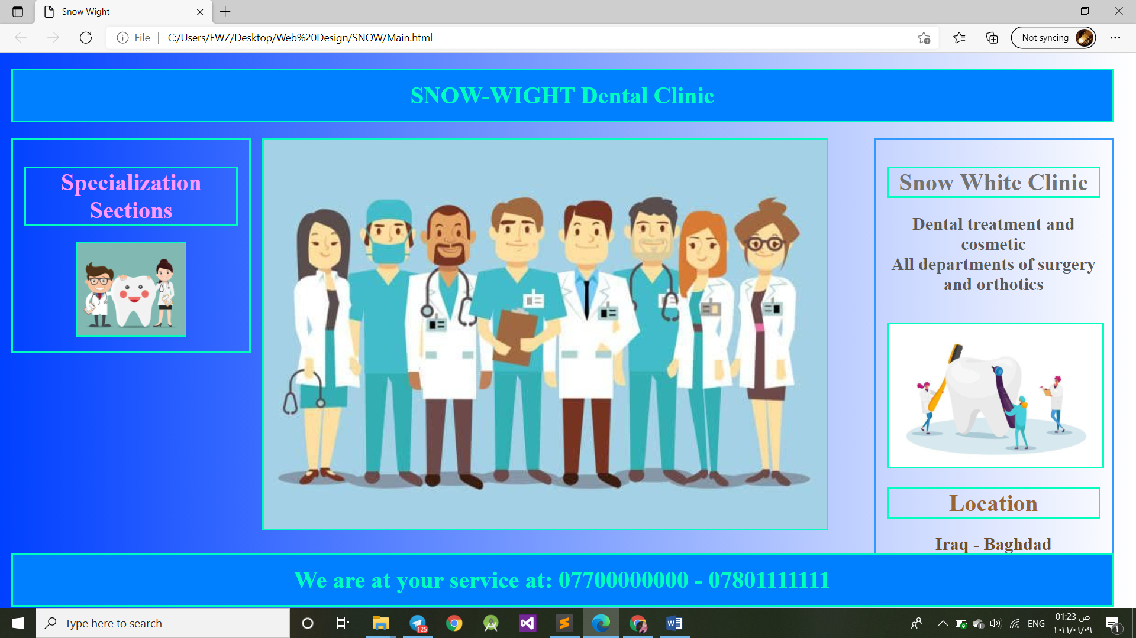

HTML Code

</strong> </p>

<IMG SRC = "LSide2.jpg" style="width: 50%">

</div>

<div id="image" >

<IMG SRC = "Dentists.jpg">

</div>

<div id="R-side">

<p class="text">

<strong>

<h1 style="color:#737373 "> Snow White Clinic </h1>

<h2 style="color:#595959 "> Dental treatment and cosmetic

<br>

All departments of surgery and orthotics </h2>

<br>

<!DOCTYPE html>

<html>

<head>

<title>Snow Wight</title>

<link rel="stylesheet" href="Main.css">

</head>

<body align="center">

<div>

<div id="child">

<h1 class="hader">SNOW-WIGHT Dental Clinic </h1>

</div>

<div id="child2">

<div id="L-side" >

<p class="text">

<strong>

<h1 style="color:#ff4dff ">

<a href="SpecializationSections.html" target="_blank">

Specialization Sections

</a> </h1>

**Manar Yhaya**

CSS Code

.hader{ border : 1% solid grey; border-style: solid;

padding: 1%; color:#00ffbf;

background: #0080ff; margin-left:1%;

margin-right:1%;

}

img{ width: 100%; height: 100%;

border : 1%; border-style: solid;

border-color: #00ffbf;}

#child { height: 24%; width: 99%;

position: relative;

}

#child2 { width: 99%; height: 50%;

position: relative; top: 50%;

position: relative; }

#L-side{ border : 1%; border-style: solid;

border-color: #00ffbf; margin-left:1%;

margin-right: 1%; width: 19%;

height: 50%; padding: 1%;

float: left;}

#image{ width: 50%; height: 50%;

float: left;}

#R-side{ border : 1%; border-style: solid;

border-color: #3399ff; margin-left: 1%;

margin-right: 1%; width: 19%;

height: 50%; padding: 1%;

float: right; position: relative;}

#child3{ margin-top:1%; margin-bottom: 1%;

position: fixed; width: 99%;

height: 23%; top: 85%;}

text{ font-family: Verdana; font-size: 99%;

size: 100%; color:red;}

body{

background: -webkit-linear-gradient(left, #0040ff, #ffffff);

margin: 0 auto;

}

h1{

border : 1%;

border-style: solid;

border-color: #00ffbf;

color: #000d1a;

}

a{

text-decoration:none;

color:#ff99ff;

}

<IMG SRC = "RSide.jpg">

<h1 style="color:#996633 "> Location </h1>

<h2 style="color:#734d26 "> Iraq - Baghdad </h2>

</strong></p>

</div>

</div>

<div id="child3">

<h1 class="hader"> We are at your service at:

07700000000 - 07801111111 </h1>

</div>

</div>

</body>

</html>

|  |  |  |  |  |
| --- | --- | --- | --- | --- |
| No. | Date | From  (hh:mm) | To  (hh:mm) | Description |
| 1 | **4/5/2021** | 10:00 pm | 11:00 pm | Meet up with team members |
| 2 | **5/6/2021** | 9:25 pm | 10:00 pm | Working in the Website |
| 3 | **7/5/2021** | 5:00 pm | 6:30 pm | Working in the Website |
| 4 | **8/6/2021** | 7:11 pm | 7:40 pm | Meet up with team members |

**Mohammed Jafar**

|  |  |  |  |  |
| --- | --- | --- | --- | --- |
| No. | Date | From  (hh:mm) | To  (hh:mm) | Description |
| 1 | **4/5/2021** | 10:00 pm | 11:00 pm | Meet up with team members |
| 2 | **6/6/2021** | 3:00 pm | 4:40 pm | Working in the Website |
| 3 | **8/5/2021** | 5:30 pm | 7:00 pm | Working in the Website |
| 4 | **8/6/2021** | 7:11 pm | 7:40 pm | Meet up with team members |

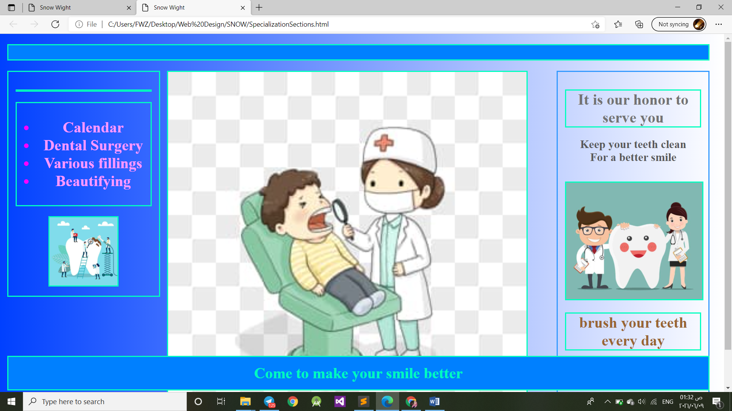

img{ width: 100%;

height: 100%;

border : 1%;

border-style: solid;

border-color: #00ffbf; }

#child { height: 24%;

width: 99%;

position: relative; }

#child2 { width: 99%;

height: 50%;

position: relative;

top: 50%;

position: relative; }

#L-side{ border : 1%;

border-style: solid;

border-color: #00ffbf;

margin-left:1%;

margin-right: 1%;

height: 50%;

padding: 1%;

float: left; }

#image{ width: 50%;

height: 50%;

float: left; }

#R-side{ border : 1%;

border-style: solid;

border-color: #3399ff;

margin-left: 1%;

<!DOCTYPE html>

<html>

<head>

<title>Snow Wight</title>

<link rel="stylesheet" href="Main.css">

<style type="text/css">

body{

background: -webkit-linear-gradient(left, #0040ff, #ffffff);

margin: 0 auto;}

.h1{

border : 1%;

border-style: solid;

border-color: #00ffbf;

color: #000d1a; }

a{

text-decoration:none;

color:#ff99ff; }

.hader{

border : 1% solid grey;

border-style: solid;

padding: 1%;

color:#00ffbf;

background: #0080ff;

margin-left:1%;

margin-right:1%;

}

CSS Code

</ul> </h1>

</strong> </p>

<IMG SRC = "p5.jpg" style="width: 50%"> </div>

<div id="image" >

<IMG SRC = "p6.jpg">

</div>

<div id="R-side"> <p class="text">

<strong>

<h1 style="color:#737373 "> It is our honor to serve you </h1>

<h2 style="color:#595959 ">Keep your teeth clean

<br>For a better smile </h2> <br> <IMG SRC = "LSide2.jpg"> <h1 style="color:#996633 "> brush your teeth every day</h1> <h2 style="color:#734d26 ">Two clean attractive appearance </h2> </strong>

</p>

</div>

</div>

<div id="child3">

<h1 class="hader">Come to make your smile better</h1>

</div>

</div>

</body>

</html>

margin-right: 1%; width: 19%;

height: 50%; padding: 1%;

float: right; position: relative;}

#child3{ margin-top:1%;

margin-bottom: 1%; position: fixed;

width: 99%; height: 23%;

top: 85%; }

.text{ font-family: Verdana;

font-size: 99%; size: 100%;

color:red; }

</style> </head>

<body align="center">

<div>

<div id="child"> <h1 class="hader"> </h1>

</div>

<div id="child2">

<div id="L-side" >

<p class="text">

<strong> <h1 style="color:#ff4dff "> </h1>

<h1 style="color:#ff00ff "> <ul> <li>

<a href="Orthodontics.html" target="_blank"> Calendar </a> </li>

<li> <a href="DentalSurger.html" target="_blank"> Dental Surgery </a> </li>

<li> <a href="DentalFillings.html" target="_blank"> Various fillings </a> </li>

<li> <a href="DentalAesthetics.html" target="_blank"> Beautifying </a> </li>



**9/6/2021**

**Linha Mohammed**

|  |  |  |  |  |
| --- | --- | --- | --- | --- |
| No. | Date | From  (hh:mm) | To  (hh:mm) | Description |
| 1 | **10/6/2021** | 12:00 am | 1:30 am | Working in the Website |
| 2 | **11/6/2021** | 5:25 pm | 6:00 pm | Meet up with team members |
| 3 | **15/6/2021** | 9:10 pm | 10:00 pm | Working in the Website |
| 4 | **13/6/2021** | 12:00 am | 12:40 pm | Working in the Website |
| 5 | **18/6/2021** | 6:00 pm | 7:00 pm | Meet up with team members |
| 6 | **19/6/2021** | 12:30 am | 1:20 am | Writing the report |

**Manar Yhaya**

|  |  |  |  |  |
| --- | --- | --- | --- | --- |
| No. | Date | From  (hh:mm) | To  (hh:mm) | Description |
| 1 | **9/6/2021** | 5:00 am | 6:30 am | Working in the Website |
| 2 | **11/6/2021** | 5:25 pm | 6:00 pm | Meet up with team members |
| 3 | **12/6/2021** | 9:00 pm | 10:30 pm | Working in the Website |
| 4 | **15/6/2021** | 5:00 am | 6:40 pm | Working in the Website |
| 5 | **18/6/2021** | 6:00 pm | 7:00 pm | Meet up with team members |

**Mohammed Jafar**

|  |  |  |  |  |
| --- | --- | --- | --- | --- |
| No. | Date | From  (hh:mm) | To  (hh:mm) | Description |
| 1 | **10/6/2021** | 11:00 pm | 12:30 am | Working in the Website |
| 2 | **11/6/2021** | 5:25 pm | 6:00 pm | Meet up with team members |
| 3 | **12/6/2021** | 2:00 pm | 3:30 pm | Working in the Website |
| 4 | **16/6/2021** | 10:00 am | 10:40 pm | Working in the Website |
| 5 | **18/6/2021** | 6:00 pm | 7:00 pm | Meet up with team members |

**Our team work**

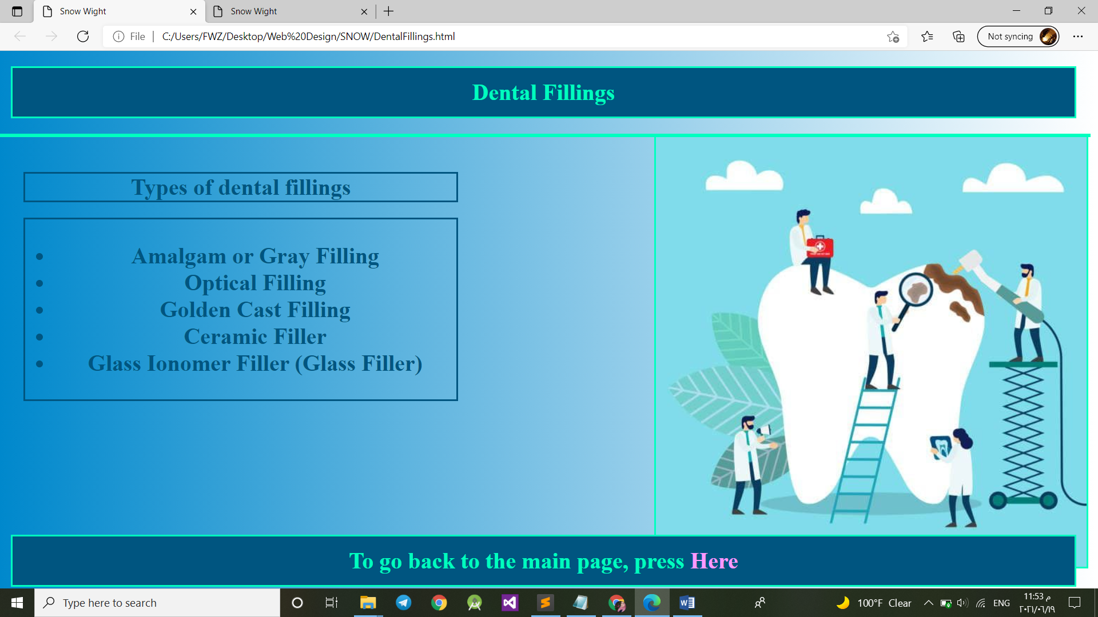

<!DOCTYPE html>

<html>

<head>

<title>Snow Wight</title>

<link rel="stylesheet" href="DentalFillings.css">

</head>

<body align="center">

<div>

<div id="child">

<h1 class="hader">Dental Fillings</h1>

</div>

<div id="child2">

<div id="L-side" >

<p class="text">

<strong>

<h1 style="border-style: solid; "> Types of dental fillings</h1>

</strong>

</p>

<h1 style="border-style: solid; ">

<P>

<ul>

<li> Amalgam or Gray Filling </li>

<li> Optical Filling </li>

<li>Golden Cast Filling</li>

<li>Ceramic Filler</li>

.hader{

border : 1% solid grey;

border-style: solid;

padding: 1%;

color:#00ffbf;

background: #005580;

margin-left:1%;

margin-right:1%; }

img{

width: 99%; height: 99%;

border : 1%; border-style: solid;

border-color: #00ffbf; }

#child {

height: 24%; width: 99%;

position: relative; }

#child2 {

width: 99%;

border : 1%; border-style: solid;

border-color: #00ffbf;

position: relative;

color:#005580;

top: 50%; }

#L-side{

margin:1%;

width: 40%; height: 99%;

padding: 1%; float: left; }

#image{

width: 40%;

height: 15%;

float: right;

}

#child3{

margin-top:1%;

margin-bottom: 1%;

position: fixed;

width: 99%;

height: 23%;

top: 85%;

}

.text{

font-family: Verdana;

font-size: 99%;

size: 100%;

}

body{

background: -webkit-linear-gradient(left, #0088cc, #ffffff);

margin: 0 auto;

}

a{

text-decoration:none;

color:#ff99ff; }

<li> Glass Ionomer Filler (Glass Filler) </li>

</ul></h1>

</P>

</div>

<div id="image">

<img src="p5.jpg"></div>

</div>

</div>

<div id="child3">

<h1 class="hader"> To go back to the main page, press <a href="Main.html" target="_blank"> Here </a> </h1>

</div>

</div>

</body>

</html>

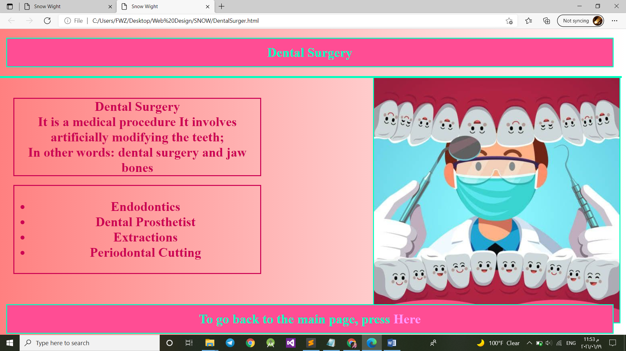

It is a medical procedure

It involves artificially modifying the teeth; <br>

In other words: dental surgery and jaw bones </h1>

</strong>

</p>

<h1 style="border-style: solid; ">

<P>

<ul>

<li> Endodontics </li>

<li> Dental Prosthetist </li>

<li> Extractions </li>

<li> Periodontal Cutting </li>

</ul></h1>

</P>

</div>

<div id="image">

<img src="LSide.jpg"></div>

</div>

</div>

<div id="child3">

<h1 class="hader"> To go back to the main page, press <a href="Main.html" target="_blank"> Here </a> </h1>

</div>

</div>

</body>

</html>

<!DOCTYPE html>

<html>

<head>

<title>Snow Wight</title>

<link rel="stylesheet" href="DentalSurgery.css">

</head>

<body align="center">

<div>

<div id="child">

<h1 class="hader"> Dental Surgery </h1>

</div>

<div id="child2">

<div id="L-side" >

<p class="text">

<strong>

<h1 style="border-style: solid; "> Dental Surgery <br>

.hader{

border : 1% solid grey;

border-style: solid;

padding: 1%;

color:#00ffbf;

background: #ff4d94;

margin-left:1%;

margin-right:1%;

}

img{

width: 99%;

height: 99%;

border : 1%;

border-style: solid;

border-color: #00ffbf;

}

#child {

height: 24%;

width: 99%;

position: relative;

}

#child2 {

width: 99%;

border : 1%;

border-style: solid;

border-color: #00ffbf;

color: #cc0052;

position: relative;

top: 50%;

}

#L-side{

margin:1%;

width: 40%;

height: 99%;

padding: 1%;

float: left;

}

#image{

width: 40%;

height: 15%;

float: right;

}

#child3{

margin-top:1%;

margin-bottom: 1%;

position: fixed;

width: 99%;

height: 23%;

top: 85%;

}

.text{

font-family: Verdana;

font-size: 99%;

size: 100%;

}

body{

background: -webkit-linear-gradient(left, #ff8080, #ffffff);

margin: 0 auto;

}

a{

text-decoration:none;

color:#ff99ff;

}

.hader{

border : 1% solid grey;

border-style: solid;

padding: 1%;

color:#00ffbf;

background: #ff4d94;

margin-left:1%;

margin-right:1%;

}

img{

width: 99%;

height: 99%;

border : 1%;

border-style: solid;

border-color: #00ffbf;

}

#child {

height: 24%;

width: 99%;

position: relative;

}

#child2 {

width: 99%;

border : 1%;

border-style: solid;

border-color: #00ffbf;

color: #cc0052;

position: relative;

top: 50%;

}

#L-side{

margin:1%;

width: 40%;

height: 99%;

padding: 1%;

float: left;

}

#image{

width: 40%;

height: 15%;

float: right;

}

#child3{

margin-top:1%;

margin-bottom: 1%;

position: fixed;

width: 99%;

height: 23%;

top: 85%;

}

.text{

font-family: Verdana;

font-size: 99%;

size: 100%;

}

</P>

</div>

<div id="image">

<img src="LSide.jpg"></div>

</div>

</div>

<div id="child3">

<h1 class="hader"> To go back to the main page, press <a href="Main.html" target="_blank"> Here </a> </h1>

</div>

</div>

</body>

</html>

#child3{

margin-top:1%;

margin-bottom: 1%;

position: fixed;

width: 99%;

height: 23%;

top: 85%;

}

.text{

font-family: Verdana;

font-size: 99%;

size: 100%;

}

color: #cc0052;

position: relative;

top: 50%;

}

#L-side{

margin:1%;

width: 40%;

height: 99%;

padding: 1%;

float: left;

}

#image{

width: 40%;

height: 15%;

float: right;

}

#child3{

margin-top:1%;

margin-bottom: 1%;

position: fixed;

width: 99%;

height: 23%;

top: 85%;

}

.text{

font-family: Verdana;

font-size: 99%;

size: 100%;

}





**2021/06/19**

**Linha Mohammed**

|  |  |  |  |  |
| --- | --- | --- | --- | --- |
| No. | Date | From  (hh:mm) | To  (hh:mm) | Description |
| 1 | **20/6/2021** | 9:10 pm | 10:00 pm | Working in the Website |
| 2 | **21/6/2021** | 6:00 pm | 6:40 pm | Meet up with team members |
| 3 | **22/6/2021** | 10:00 pm | 10:30 pm | Working in the Website |
| 4 | **23/6/2021** | 6:00 pm | 7:00 pm | Meet up with team members |
| 6 | **24/6/2021** | 6:30 am | 7:20 am | Writing the report |

**Manar Yhaya**

|  |  |  |  |  |
| --- | --- | --- | --- | --- |
| No. | Date | From  (hh:mm) | To  (hh:mm) | Description |
| 1 | **20/6/2021** | 11:00 pm | 11:30 pm | Working in the Website |
| 2 | **21/6/2021** | 6:00 pm | 6:40 pm | Meet up with team members |
| 3 | **21/6/2021** | 10:00 pm | 10:30 pm | Working in the Website |
| 4 | **23/6/2021** | 6:00 pm | 7:00 pm | Meet up with team members |

**Mohammed Jafar**

|  |  |  |  |  |
| --- | --- | --- | --- | --- |
| No. | Date | From  (hh:mm) | To  (hh:mm) | Description |
| 1 | **20/6/2021** | 5:10 am | 6:00 am | Working in the Website |
| 2 | **21/6/2021** | 6:00 pm | 6:40 pm | Meet up with team members |
| 3 | **22/6/2021** | 7:00 pm | 7:30 pm | Working in the Website |
| 4 | **23/6/2021** | 6:00 pm | 7:00 pm | Meet up with team members |

ES=38, EF=41

ES=16, EF=38

**Activity networks of the MIS problem && Earliest start and finish dates**

ES=42, EF=45

ES=41, EF=42

ES=12, EF=16

ES=9, EF=12

ES=6, EF=9

ES=0, EF=6

Finish

**Meeting with group members**

**(3 Days)**

**Writing up the project report**

**(3 Days)**

**Preparing presentation (1 Days)**

**Literature review**

**(4 Days)**

**Preparing problem statement**

**(6 Days)**

**Implementation**

**(22 Days)**

**Understanding general**

**(3 Days)**

**Testing**

**(3 Days)**

Start

**2021/07/8**



1. **Meet with people.**
2. **Meet the Doctor.**
3. **https://mawdoo3.com/%D8%A3%D9%87%D9%85%D9%8A%D8%A9_%D8%A7%D9%84%D9%85%D9%88%D8%A7%D9%82%D8%B9_%D8%A7%D9%84%D8%A5%D9%84%D9%83%D8%AA%D8%B1%D9%88%D9%86%D9%8A%D8%A9.**
4. **<http://scholar.ppu.edu/handle/123456789/1806?show=full>.**